Baptisms at St Mary’s, Bungendore and
Saints Peter and Paul’s Hoskinstown and
Saint Joseph’s Gundaroo
general information
St Mary’s Parish welcomes your family and your new little one to our community.
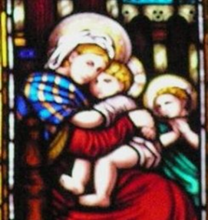
Jesus took a little child and set him by his side and then said to his disciples, ‘Anyone who welcomes this little child in my name welcomes me; and anyone who welcomes me welcomes the one who sent me.’ Luke 9: 47

TIMES: At St Mary's Church, Bungendore baptisms are held on the 1st & 3rd Sunday of the month after 8.30am Mass at 9.45am. St Joseph’s Gundaroo, usually after the Sunday 10.30am Mass, 2nd or 4th Sunday.
At Sts Peter and Paul's Church, Hoskinstown, baptisms are by appointment. Please speak to the office to find a suitable time for your family.
We are currently conducting baptisms one family at a time.
MAKING A BOOKING FOR A BAPTISM:- You can phone the Bungendore parish office on 6238 1247 between 10.30am and 5pm on Wednesdays or Thursdays 9am-3.30pm. The "Request for Baptism" form can also be downloaded from our parish page on the Archdiocesan website Application Forms (cg.org.au) and completed and emailed to St Mary’s Parish bungendore@cg.org.au
GODPARENTS: You need at least one Godparent but we have space to record up to four in the Parish Register. Godparents' names will appear on the Baptismal Certificate and in the Parish Register. A Godparent needs to: have received the sacraments of Baptism, Holy Communion and Confirmation; be at least sixteen years old; and not be one of the parents. Any other validly baptised person is welcome to be a Christian witness.
TWO NON-CATHOLIC PARENTS: If neither parent is a Catholic, you will need to speak with the Priest or Deacon before booking a Baptism.
OLDER CHILD BAPTISM: If your child is over 6 years old, you will need to speak to the Parish Priest or Deacon for advice on preparing your child to be baptised.

